**Part-1 Complete Set Up for Hello Custom**

After creating the project

Configure cloud shell to use the project

gcloud config set project hellocustom

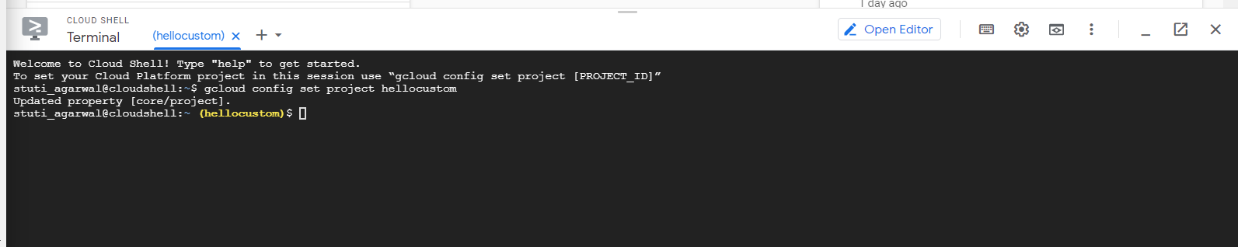

Hellocustom bucket created

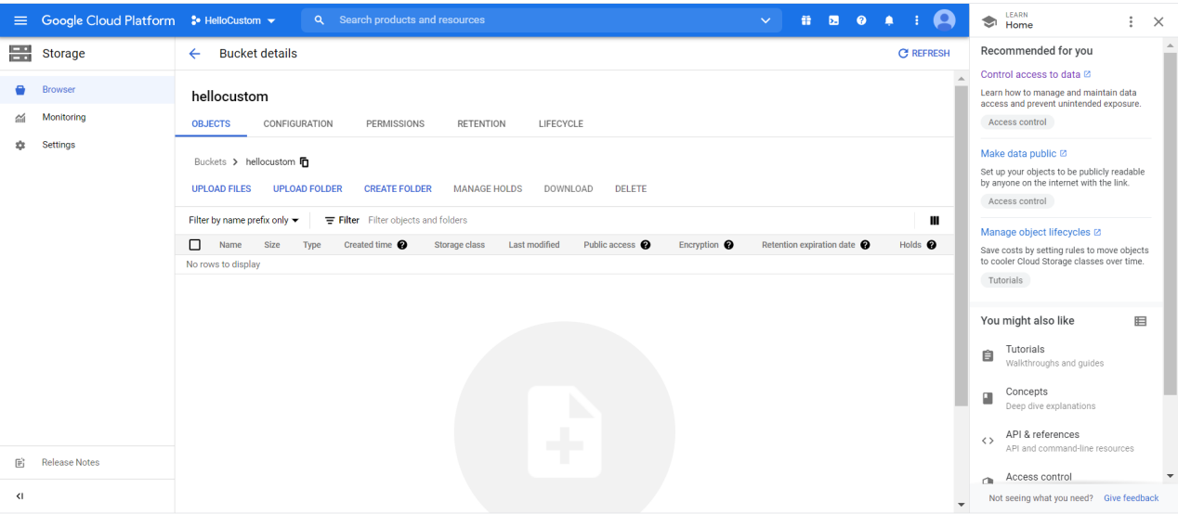

Downloading the sample code

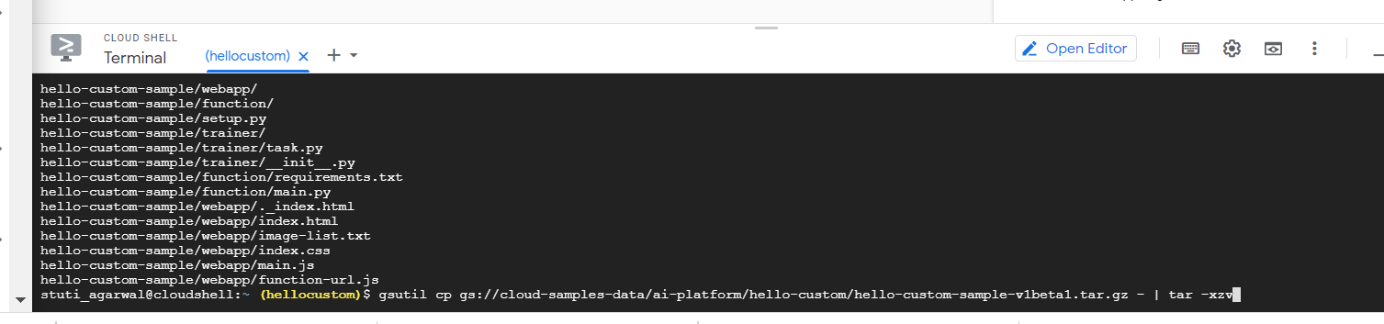

Checking the directory structure of hello-custom-sample

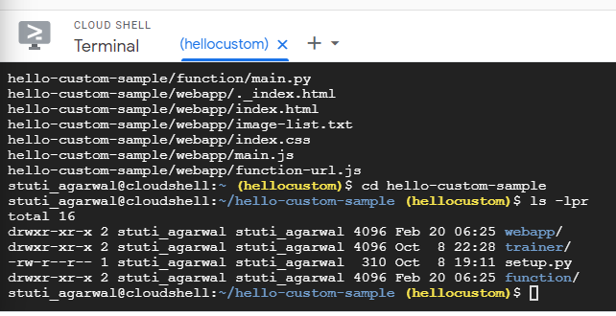

Creating a source distribution in the gzipped tarball format

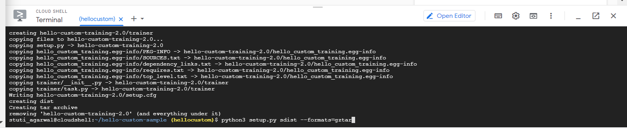

Uploading hello-custom-training-2.0.tar.gz to Cloud storage bucket

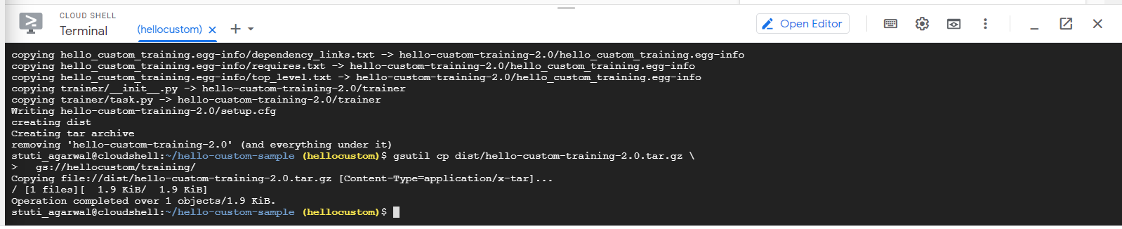

Training the model

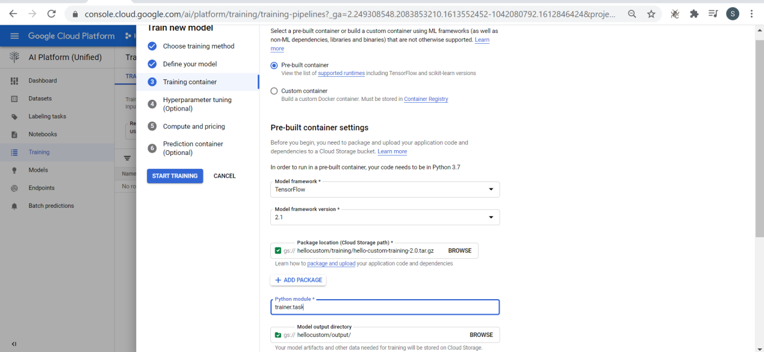

Training started

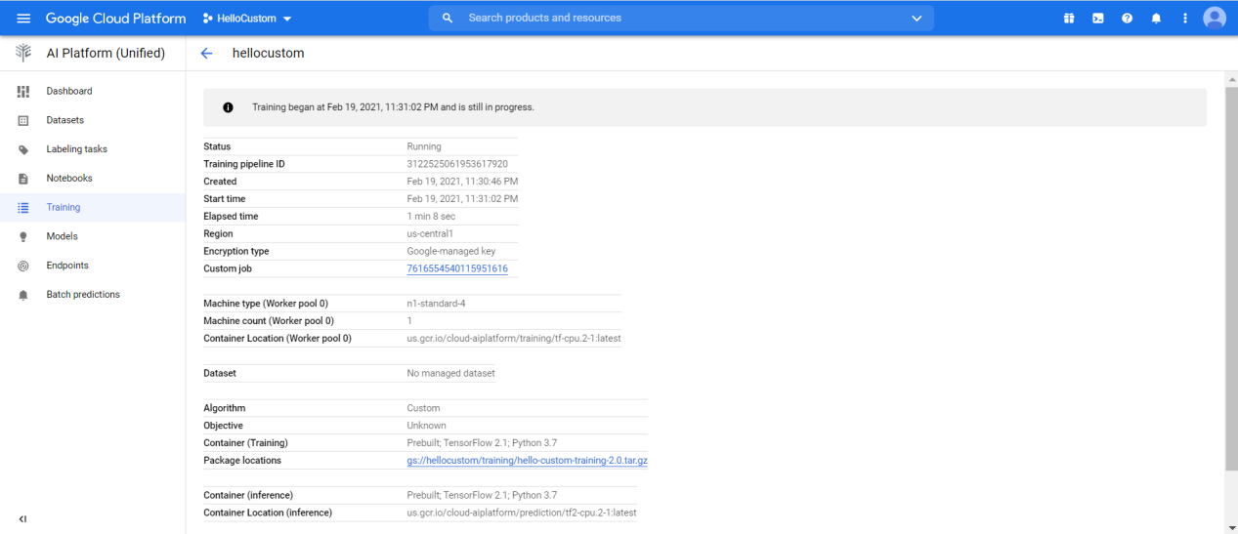

Hellocustomjob resource created

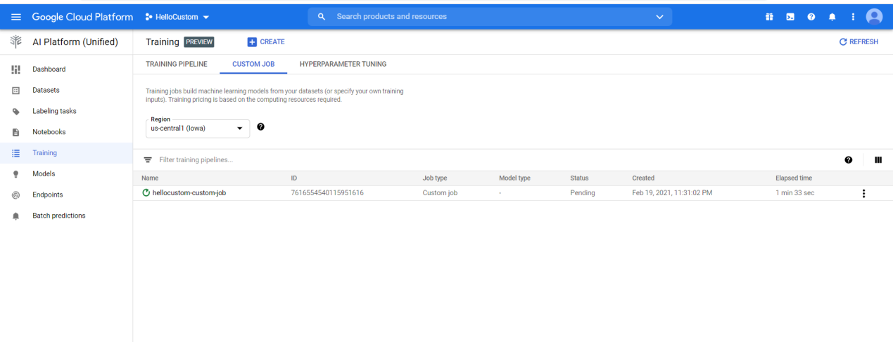

Trained model can be found

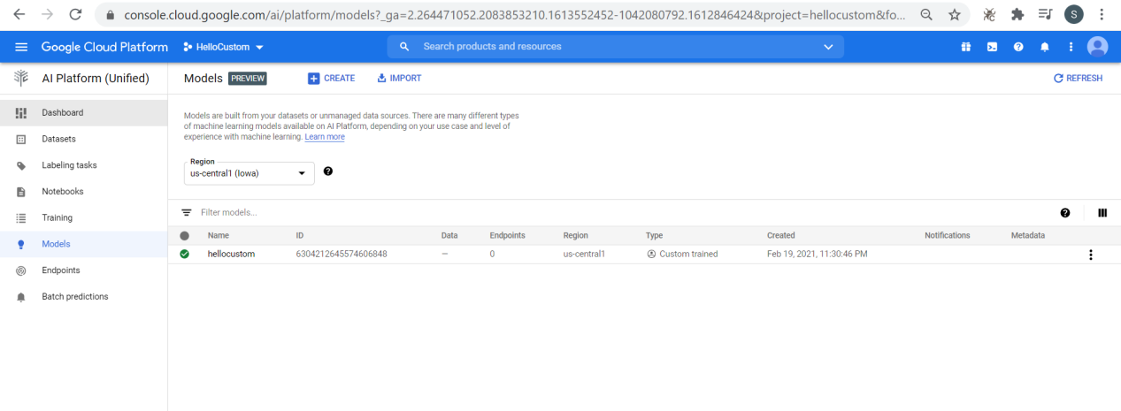

Creation of endpoint

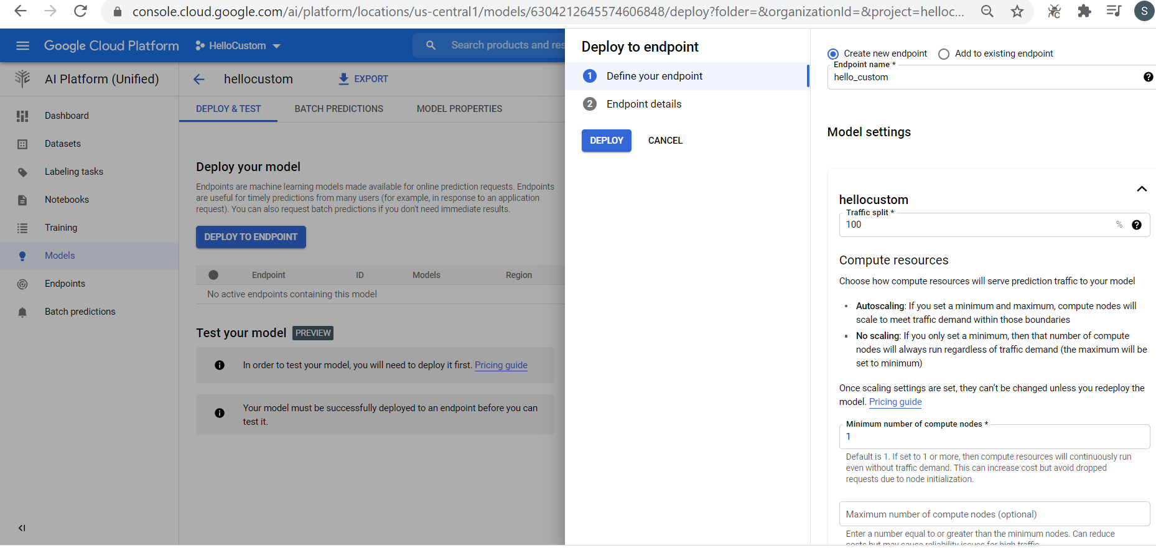

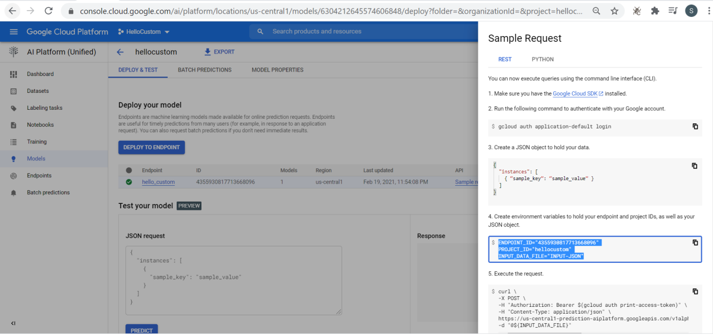

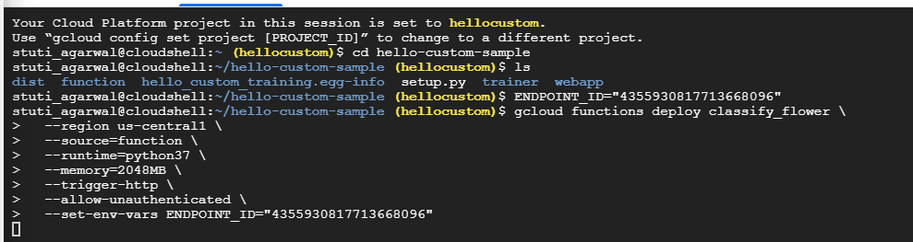

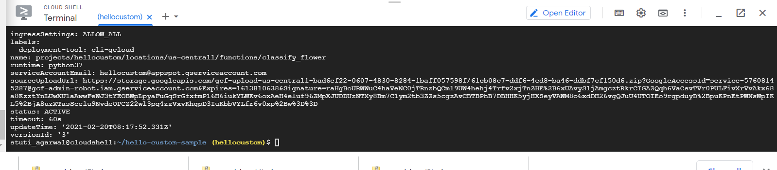

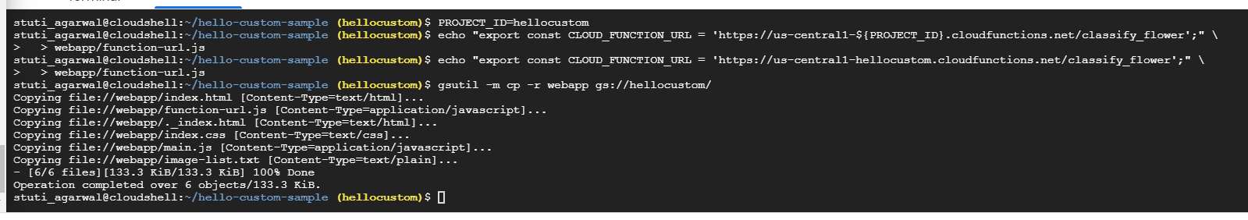

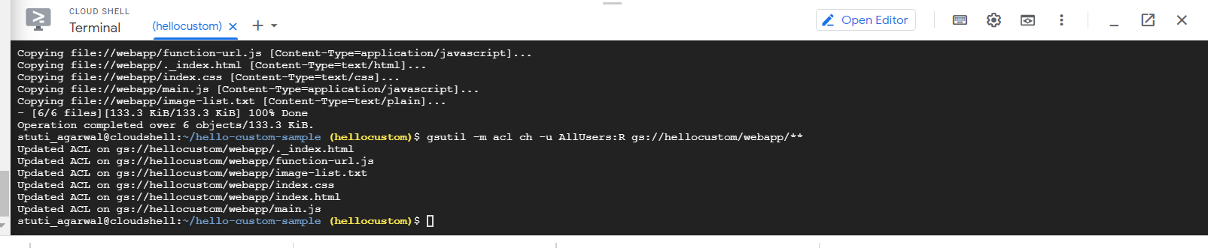

<https://storage.googleapis.com/hellocustom/webapp/index.html>

